**Supporting Information**  
Figure S1: Wild-bee abundance and species richness in spring (prior to May 15th) and summer/fall (after May 15th) at locations in Maryland, Delaware, and Washington DC. All locations were sampled by the United States Geological Survey Native Bee Inventory and Monitoring Lab (USGS BIML) from 2003-2013. We estimated species richness using coverage-based rarefaction methods (Chao and Jost 2012; Hsieh et al. 2016).

## Table S1:Classification of USDA NASS Cropland Data Layer into categories of arable, natural, and developed land use.

Table S1 (continued):Classification of USDA NASS Cropland Data Layer into categories of arable, natural, and developed land use.



Figure S2: Composition of landscapes surrounding locations in Maryland, Delaware, and Washington DC where the United States Geological Survey Native Bee Inventory and Monitoring Lab (USGS BIML) collected wild bees from 2003-2013.

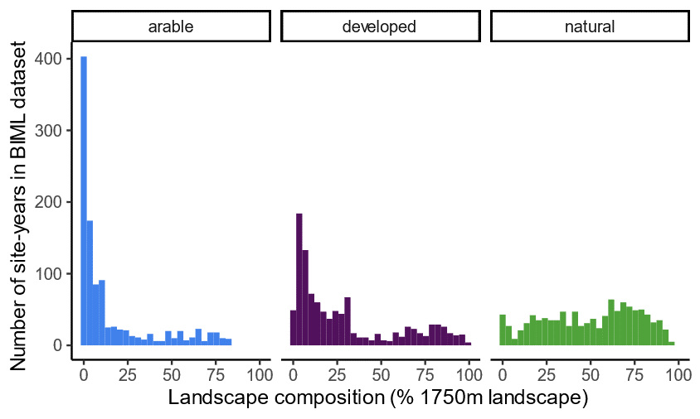

Figure S3: Land-use class at each of 976 site-years sampled by the United States Geological Survey Native Bee Inventory and Monitoring Lab (USGS BIML) from 2003-2013. Land-use classes are from USDA NASS Cropland Data Layer matching the year when bees were sampled.

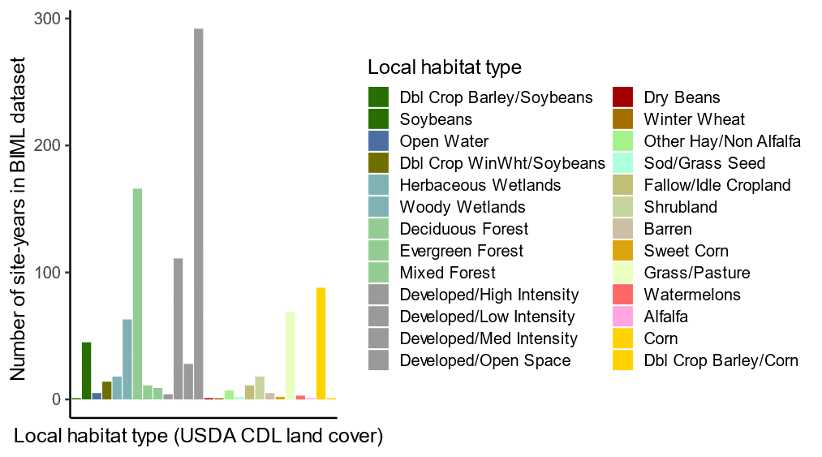

Table S2: Cumulative time and effort (number of traps * number of days) of United States Geological Survey Native Bee Inventory and Monitoring Lab (USGS BIML) wild-bee sampling from 2003-2013. Local habitat types were defined by the land cover class (USDA NASS Cropland Data Layer) matching the location and year of bee sampling.



Table S3: Functional traits of most abundant, non-parasitic species of wild bees in the USGS BIML dataset.

Table S3 (continued): Functional traits of most abundant, non-parasitic species of wild bees in the USGS BIML dataset.



Table S3 (continued): Functional traits of most abundant, non-parasitic species of wild bees in the USGS BIML dataset.



Figure S4: Non-metric multidimensional scaling ordination of wild-bee communities based on proportional abundance of bees captured per week. Each colored point represents a unique sampling time (all samples collected within a given week, Panel A), and grey points are species centroids (Panel B). For visualization purpose, only 18 species with most extreme axis loadings were labeled. Stress values were 0.125 and 0.127, for panels A and B, respectively.

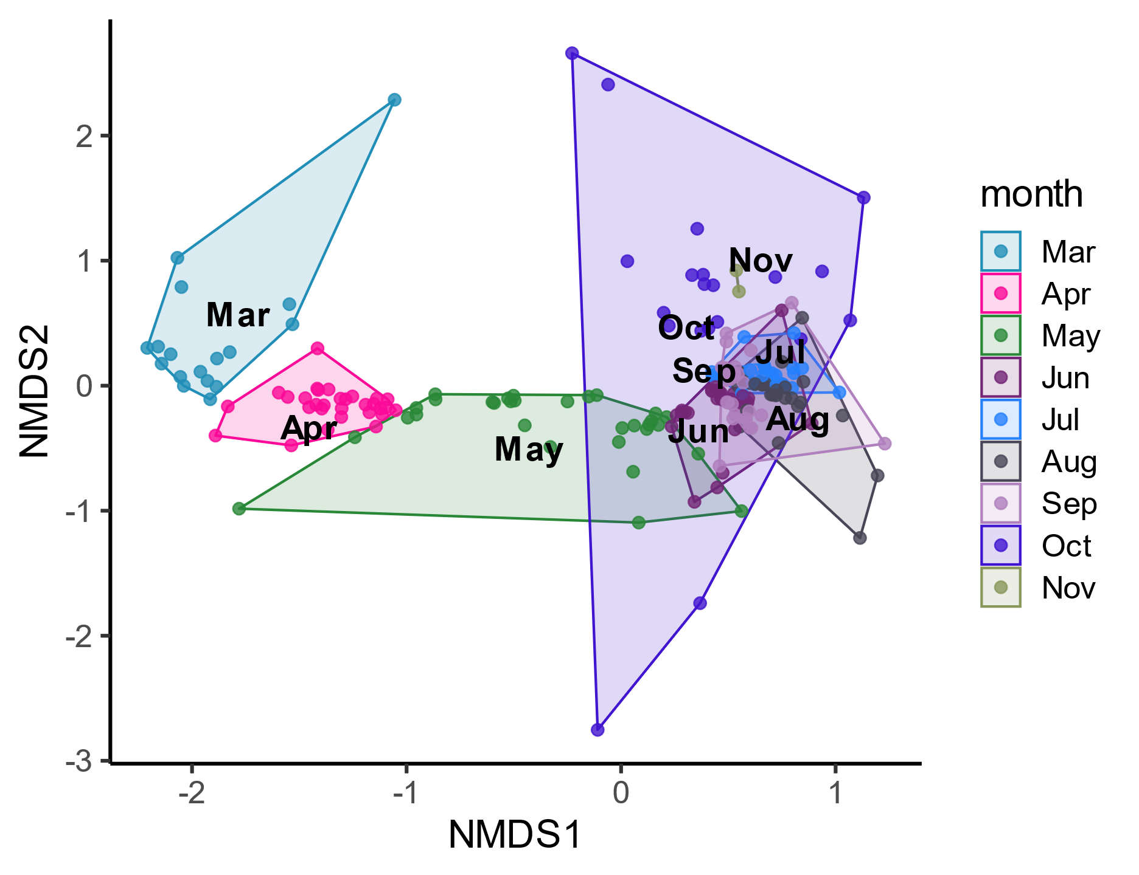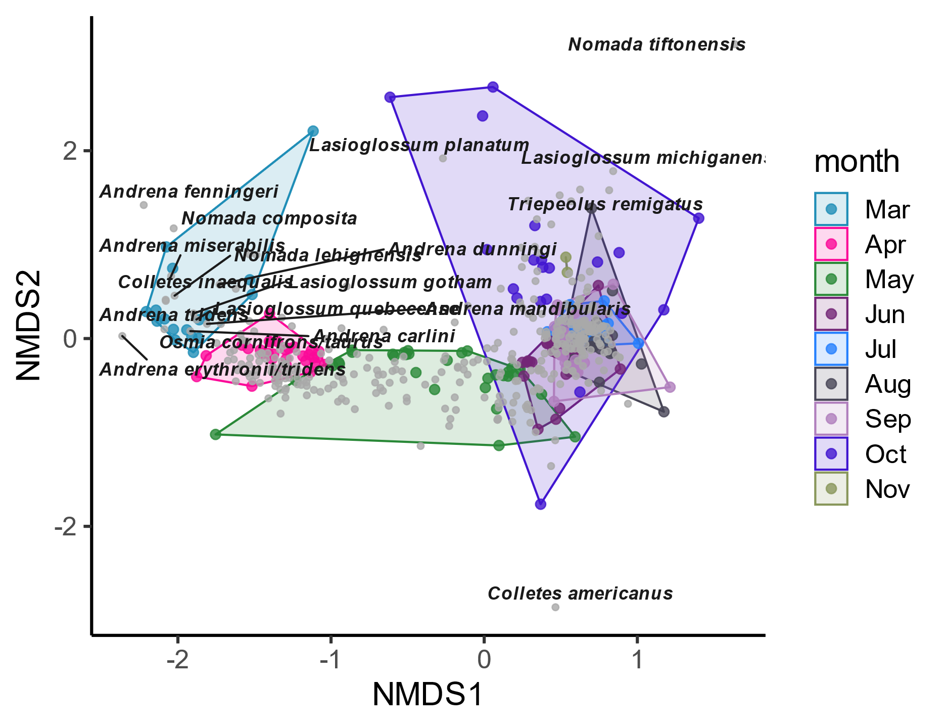

**B)**

**A)**

Figure S5: Correlation between landscape composition at 250m, 500m, and 1750m radii surrounding BIML sampling locations.

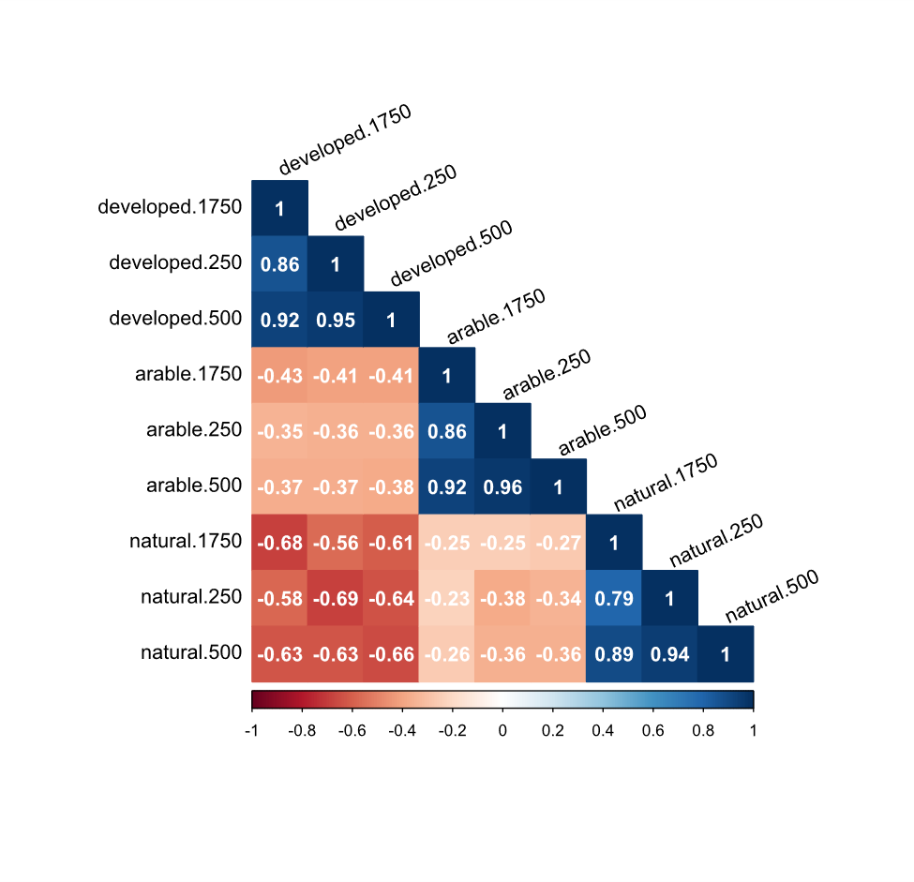

**Fourth-corner analysis**

To explore the interaction between bee functional traits and landscape and climate variables, we used a model-based fourth corner analysis (Legendre et al. 1997; Brown et al. 2014). The fourth corner modeling approach fits statistical models to predict species abundance as a function of environmental variables, species traits, and the interaction between environment and traits (Legendre et al. 1997). Model coefficients associated with environment-trait interactions coefficients represent the degree to which the relationship between abundance and environment varies as traits vary. These interaction coefficients can be interpreted as the change in the slope of the relationship between abundance and a specific environmental variable with a one standard deviation change in the trait variable. We estimated environment-trait interaction coefficients using the *mvabund* package 4.0.1 (Wang et al. 2019) with a LASSO-penalized negative binomial regression model. The LASSO-penalty completes model selection by removing (setting to zero) interaction coefficients that do not reduce the model selection metric (Bayesian Information Criterion, .Burnham and Anderson 2004). We also included ‘species effect’ to model a different intercept for each species so traits predict changes in relative abundance rather than absolute abundance.

**Fourth-corner results**

We found that summer/fall bees that vary in sociality and native status have substantially different responses to landscape composition and climate (Figure S1). Spring bees had much weaker trait-environment interactions, indicating that the spring bee community responds to environmental variation much more homogeneously than the summer/fall community. In the spring, the strongest trait-environment interaction coefficient indicated a negative association between solitary bees and developed land, but, for spring bees, this was the only coefficient greater than 0.15. Based on this analysis, for spring bees, we compared genus-level responses to landscape and climate, rather than splitting the community based on functional traits. For summer/fall bees, we selected three pairs of functional traits (native vs. non-native, eusocial vs. solitary and cavity/stem vs. ground nesting) to include in our random forest analysis.

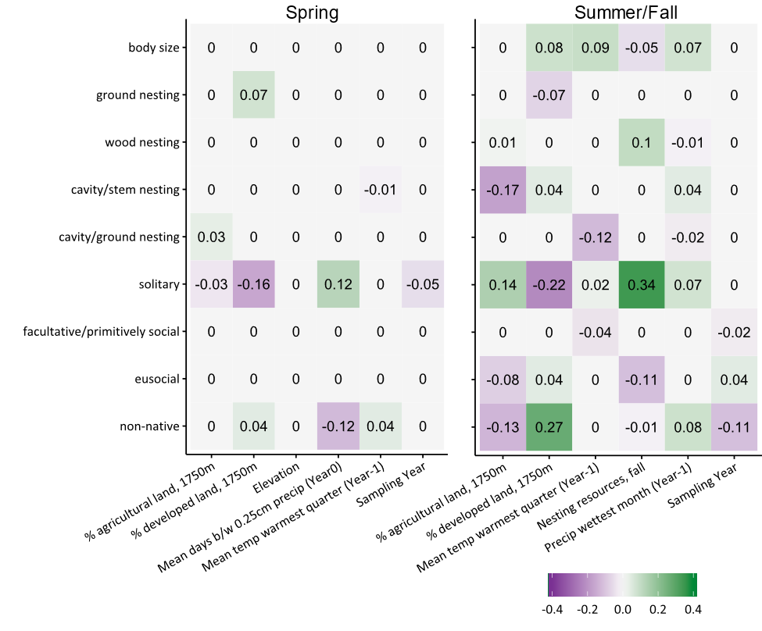Figure S6: Results of a fourth-corner analysis of spring and summer/fall communities of wild bees. Data are from USBS Native Bee Monitoring and Inventory Lab (Droege and Sellers 2017; Kammerer et al. 2020a, b).

Table S4: Bee community data, by species, used to parameterize InVEST crop pollination model. Foraging activity and relative abundance data are from the USGS BIML dataset. We compiled location and foraging range information from the literature (Michener 2007; Bartomeus et al. 2013; Danforth 2015).



Table S5: Bee community for InVEST crop pollination model summarized by nesting location. Foraging activity and relative abundance data are from the USGS BIML dataset. We compiled location and foraging range information from the literature (Michener 2007; Bartomeus et al. 2013; Danforth 2015).



Table S6: Random forest model performance predicting abundance or richness of wild bees. Unlike random forest results presented in the main manuscript (Table 2), here, response variables were original values (not z-score normalized). The R-squared, root mean squared error (RMSE), and mean absolute error (MAE) were calculated using 10-fold cross validation performed three times and are presented as mean ± standard deviation. Parameters mtry and ntree are the optimal values (for number of variables and number of trees, respectively) for each random forest model as determined by grid-search parameter tuning.

Table S7: Variable importance (‘VI’) scores for wild-bee abundance and richness models, including all bee species, top three genera of spring bees, and functional trait groups of summer bees. Weather and climate variable represent conditions in the year bees were sampled (‘.BF0’ suffix), one year before bee sampling (‘.BF1’ suffix) and a 15 year climate average (2001-2015, variables beginning with ‘q1’ or ‘q9’). ‘bc’ denotes BIOCLIM variables. 

Table S7 (continued): Variable importance (‘VI’) scores for wild-bee abundance and richness models, including all bee species, top three genera of spring bees, and functional trait groups of summer bees. Weather and climate variable represent conditions in the year bees were sampled (‘.BF0’ suffix), one year before bee sampling (‘.BF1’ suffix) and a 15 year climate average (2001-2015, variables beginning with ‘q1’ or ‘q9’). ‘bc’ denotes BIOCLIM variables. 

Table S7 (continued): Variable importance (‘VI’) scores for wild-bee abundance and richness models, including all bee species, top three genera of spring bees, and functional trait groups of summer bees. Weather and climate variable represent conditions in the year bees were sampled (‘.BF0’ suffix), one year before bee sampling (‘.BF1’ suffix) and a 15 year climate average (2001-2015, variables beginning with ‘q1’ or ‘q9’). ‘bc’ denotes BIOCLIM variables. 

Table S7 (continued): Variable importance (‘VI’) scores for wild-bee abundance and richness models, including all bee species, top three genera of spring bees, and functional trait groups of summer bees. Weather and climate variable represent conditions in the year bees were sampled (‘.BF0’ suffix), one year before bee sampling (‘.BF1’ suffix) and a 15 year climate average (2001-2015, variables beginning with ‘q1’ or ‘q9’). ‘bc’ denotes BIOCLIM variables.



Table S7 (continued): Variable importance (‘VI’) scores for wild-bee abundance and richness models, including all bee species, top three genera of spring bees, and functional trait groups of summer bees. Weather and climate variable represent conditions in the year bees were sampled (‘.BF0’ suffix), one year before bee sampling (‘.BF1’ suffix) and a 15 year climate average (2001-2015, variables beginning with ‘q1’ or ‘q9’). ‘bc’ denotes BIOCLIM variables. 

Table S7 (continued): Variable importance (‘VI’) scores for wild-bee abundance and richness models, including all bee species, top three genera of spring bees, and functional trait groups of summer bees. Weather and climate variable represent conditions in the year bees were sampled (‘.BF0’ suffix), one year before bee sampling (‘.BF1’ suffix) and a 15 year climate average (2001-2015, variables beginning with ‘q1’ or ‘q9’). ‘bc’ denotes BIOCLIM variables. 

Table S7 (continued): Variable importance (‘VI’) scores for wild-bee abundance and richness models, including all bee species, top three genera of spring bees, and functional trait groups of summer bees. Weather and climate variable represent conditions in the year bees were sampled (‘.BF0’ suffix), one year before bee sampling (‘.BF1’ suffix) and a 15 year climate average (2001-2015, variables beginning with ‘q1’ or ‘q9’). ‘bc’ denotes BIOCLIM variables. 

Table S7 (continued): Variable importance (‘VI’) scores for wild-bee abundance and richness models, including all bee species, top three genera of spring bees, and functional trait groups of summer bees. Weather and climate variable represent conditions in the year bees were sampled (‘.BF0’ suffix), one year before bee sampling (‘.BF1’ suffix) and a 15 year climate average (2001-2015, variables beginning with ‘q1’ or ‘q9’). ‘bc’ denotes BIOCLIM variables. 

Table S7 (continued): Variable importance (‘VI’) scores for wild-bee abundance and richness models, including all bee species, top three genera of spring bees, and functional trait groups of summer bees. Weather and climate variable represent conditions in the year bees were sampled (‘.BF0’ suffix), one year before bee sampling (‘.BF1’ suffix) and a 15 year climate average (2001-2015, variables beginning with ‘q1’ or ‘q9’). ‘bc’ denotes BIOCLIM variables. 

Table S7 (continued): Variable importance (‘VI’) scores for wild-bee abundance and richness models, including all bee species, top three genera of spring bees, and functional trait groups of summer bees. Weather and climate variable represent conditions in the year bees were sampled (‘.BF0’ suffix), one year before bee sampling (‘.BF1’ suffix) and a 15 year climate average (2001-2015, variables beginning with ‘q1’ or ‘q9’). ‘bc’ denotes BIOCLIM variables.



**References**

Bartomeus I, Ascher JS, Gibbs J, et al (2013) Data from: Historical changes in northeastern US bee pollinators related to shared ecological traits. Dryad Digital Repository

Brown AM, Warton DI, Andrew NR, et al (2014) The fourth-corner solution - using predictive models to understand how species traits interact with the environment. Methods Ecol Evol 5:344–352. https://doi.org/10.1111/2041-210X.12163

Burnham KP, Anderson DR (2004) Multimodel Inference: Understanding AIC and BIC in Model Selection. Sociol Methods Res 33:261–304. https://doi.org/10.1177/0049124104268644

Chao A, Jost L (2012) Coverage-based rarefaction and extrapolation: standardizing samples by completeness rather than size. Ecology 93:2533–2547. https://doi.org/10.1890/11-1952.1

Danforth B (2015) Bees of New York. https://pollinator.cals.cornell.edu/wild-bees-new-york/species-list-bees-new-york/

Droege S, Sellers E (2017) USGS PWRC - Native Bee Inventory and Monitoring Lab (BIML). Version 1.5. United States Geological Survey. Occurrence Dataset. https://doi.org/10.15468/6autvb

Hsieh TC, Ma KH, Chao A (2016) iNEXT: an R package for rarefaction and extrapolation of species diversity (Hill numbers). Methods Ecol Evol 7:1451–1456. https://doi.org/10.1111/2041-210X.12613

Kammerer M, Tooker JF, Grozinger CM (2020a) A long-term dataset on wild bee abundance in Mid-Atlantic United States. figshare

Kammerer M, Tooker JF, Grozinger CM (2020b) A long-term dataset on wild bee abundance in Mid-Atlantic United States. Sci Data 7:240. https://doi.org/10.1038/s41597-020-00577-0

Legendre P, Galzin R, Harmelin-Vivien ML (1997) Relating behavior to habitat: solutions to the fourth-corner problem. Ecology 78:547–562. https://doi.org/10.1890/0012-9658(1997)078[0547:RBTHST]2.0.CO;2

Michener CD (2007) The Bees of the World, Second Edition. The Johns Hopkins University Press, Baltimore, MD

Wang Y, Naumann U, Eddelbuettel D, Wilshire J (2019) mvabund: Statistical Methods for Analysing Multivariate Abundance Data. Version 4.0.1URL https://CRAN.R-project.org/package=mvabund